Asimov and Laurance Who Done It? Ellery Queen Mystery Club 1980, A fine unclipped dust jacket but without a price. Fine hard cover with all 229 pages tightly bound and no marks except for symbols on bottom and front of page edges and the name of the former owner on the first page after the inside of the cover. ISBN 0395291666
Seventeen stories by well-known mystery writers, whose names are coded and must be deduced by the reader, take in a tantalizing range of moods and mysteries. The last page tells you how to break the code. You're supposed to read a story and then figure out who wrote it. Authors include Robert Bloch, Edward D. Hoch, Bill Pronzini, and R. A. Lafferty. Asimov introduces each story and provides a Foreward on Style. Very collectable. Fine, tight, sharp-cornered, unread copy

ID 000182 Price $45.00 Box 2
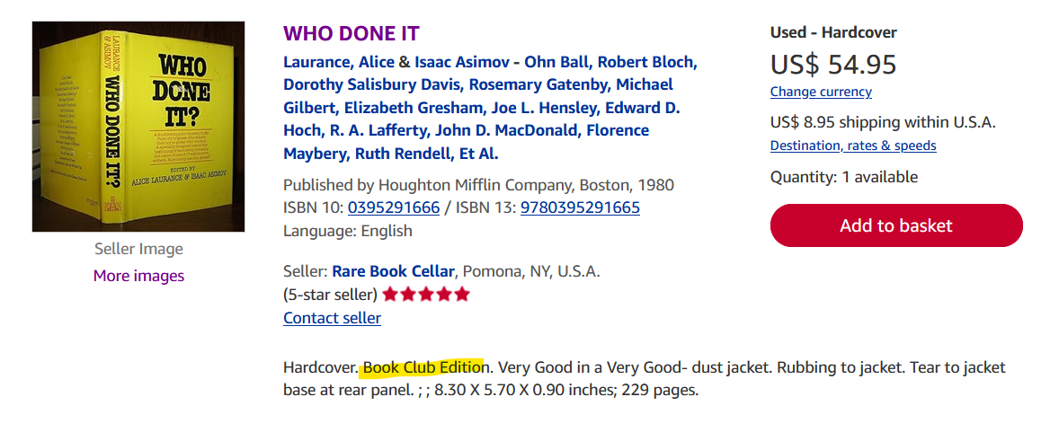

Abe Books

